Name: Zuriel G. Montallana

Year/Block: BSIT3 – B1

**1. Is your browser running HTTP version 1.0 or 1.1? What version of HTTP is the  
server running?**

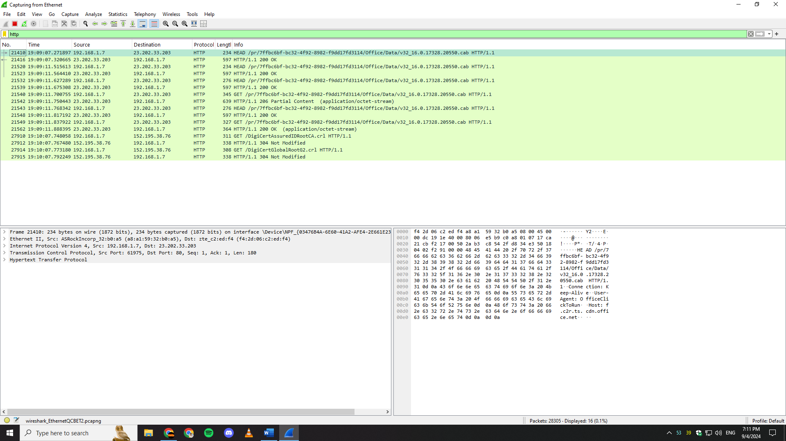

My browser is running version 1.1

**2. What languages (if any) does your browser indicate that it can accept to the  
server?**

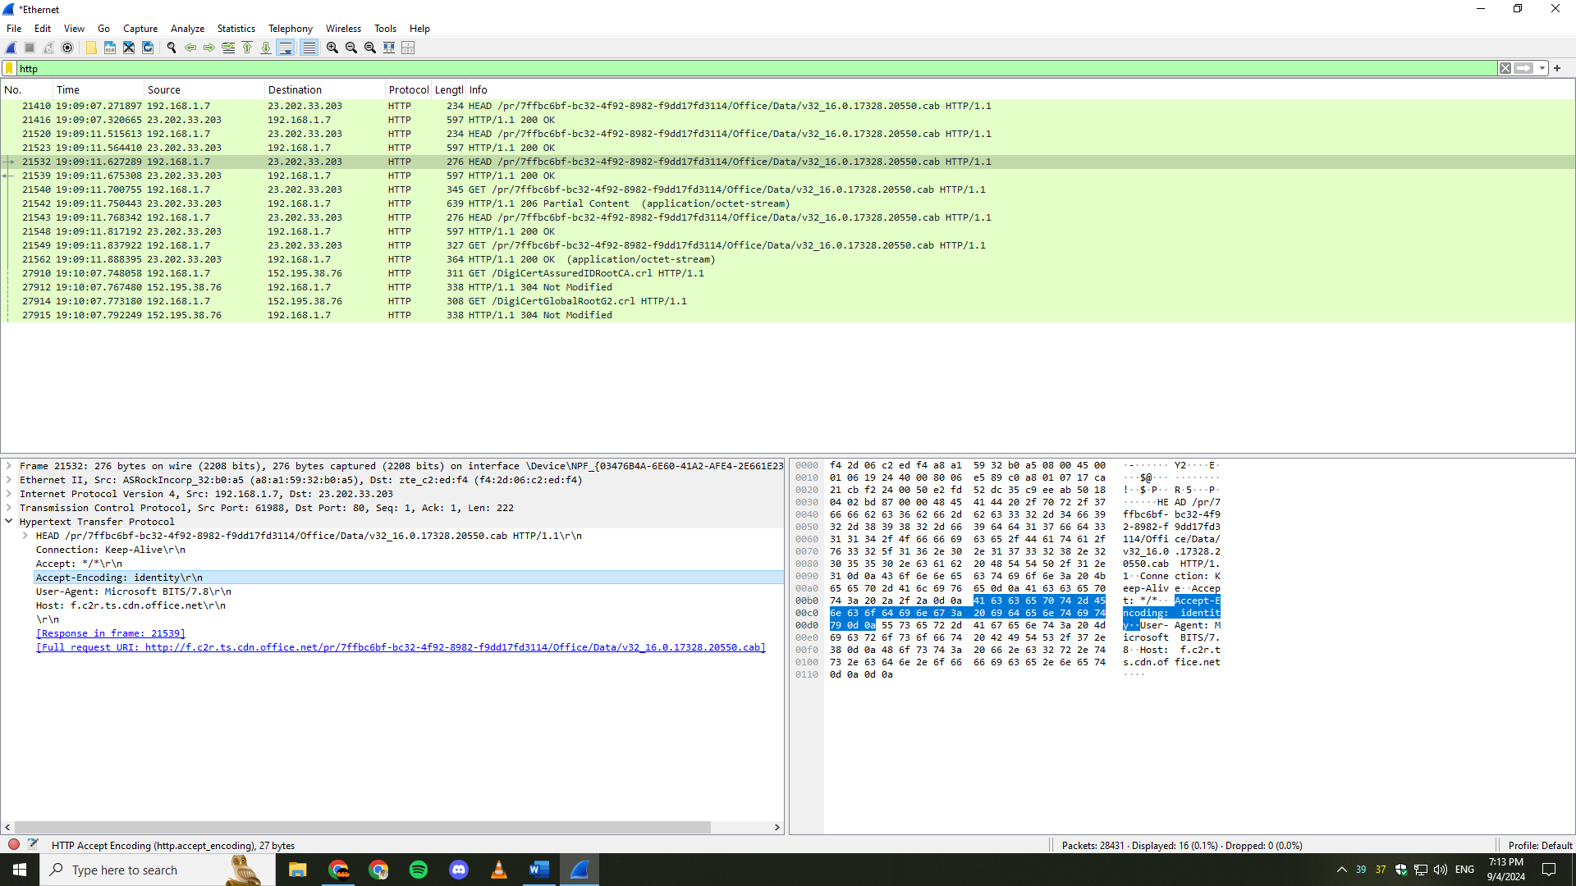

It didn’t show any languages that accepts to the server.

**3. What is the IP address of your computer? Of the gaia.cs.umass.edu server?**

192.168.1.7 and 23.202.33.203

**4. What is the status code returned from the server to your browser?**

200 OK

**5. When was the HTML file that you are retrieving last modified at the server?**

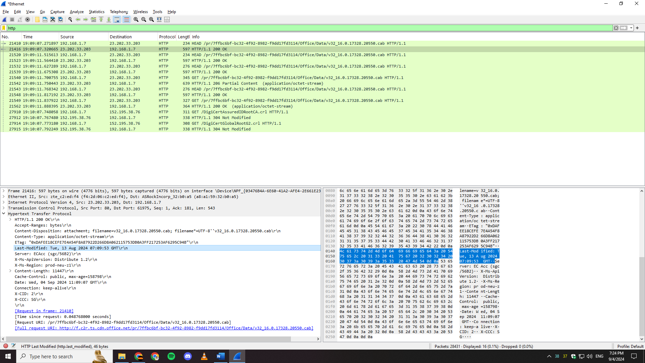

Tue, 13 Aug, 2024 07:09:53 GMT

**6. How many bytes of content are being returned to your browser?**

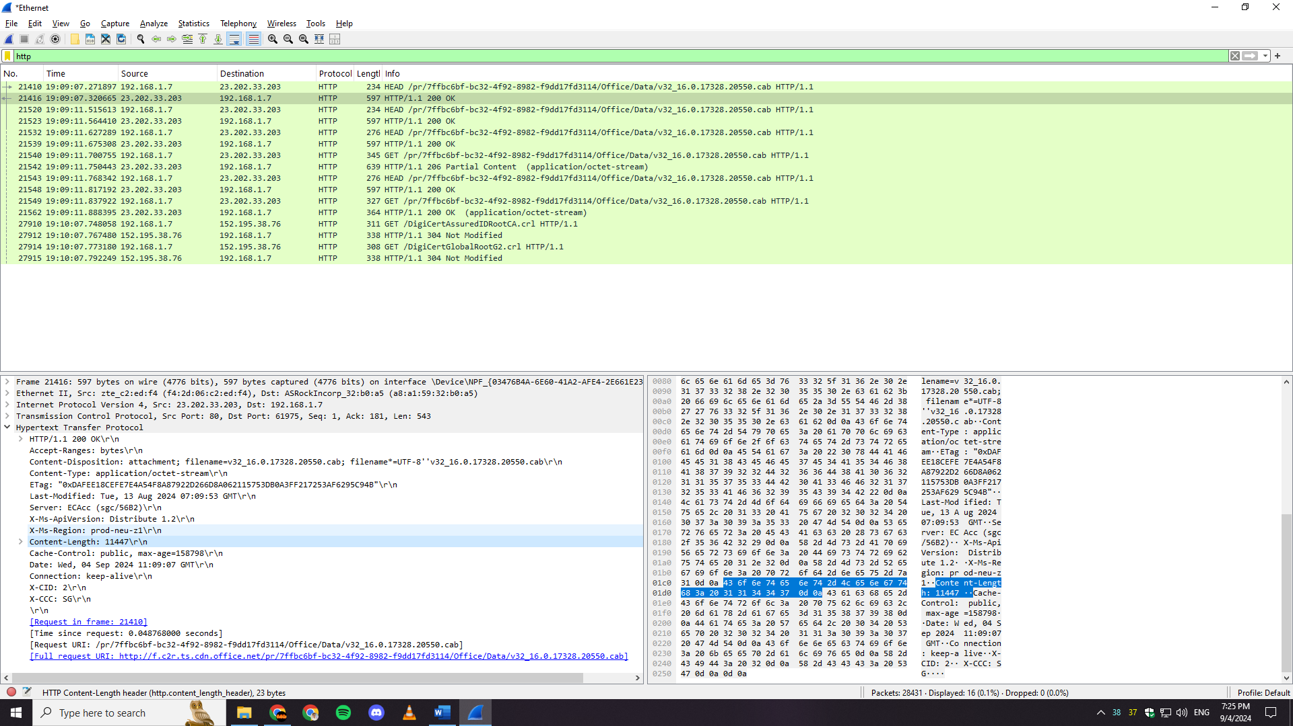

11447

**7. By inspecting the raw data in the packet content window, do you see any headers  
within the data that are not displayed in the packet-listing window? If so, name  
one.**

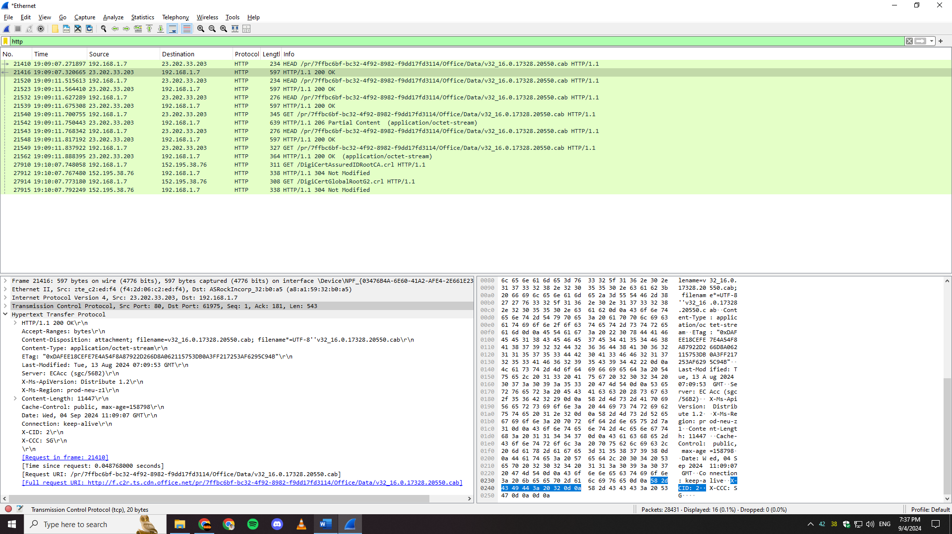

All headers are present.

**8. Inspect the contents of the first HTTP GET request from your browser to the  
server. Do you see an “IF-MODIFIED-SINCE” line in the HTTP GET?**

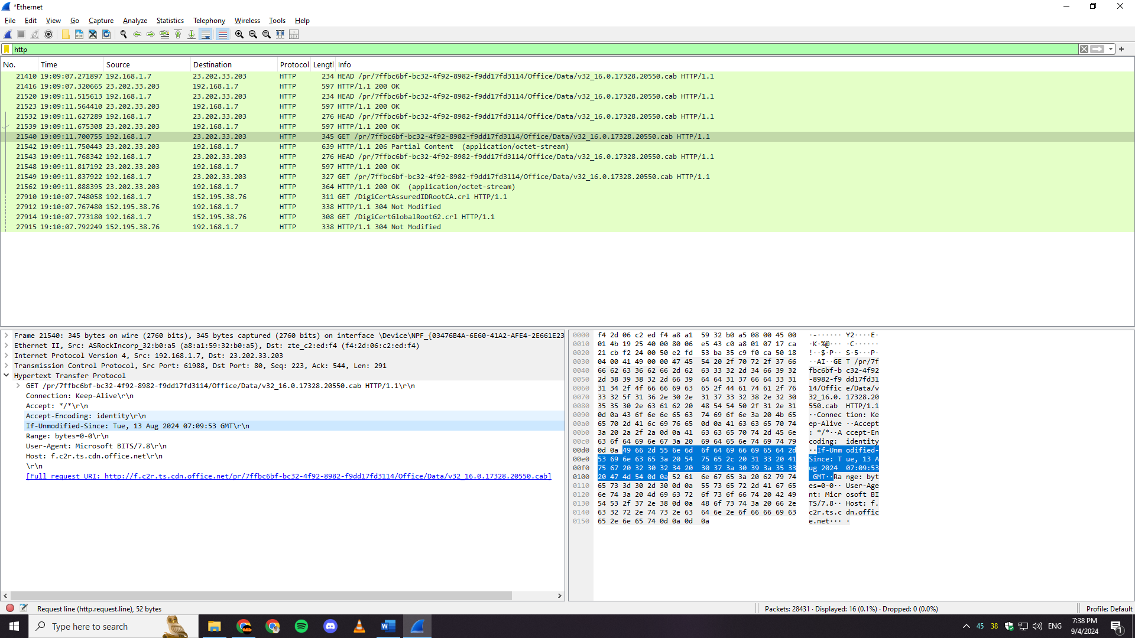

Yes

**9. Inspect the contents of the server response. Did the server explicitly return the  
contents of the file? How can you tell?**

It didn’t, because it didn’t show the body of html which should be like <html><body>This is a simple HTML file</body></html>

**10. Now inspect the contents of the second HTTP GET request from your browser to  
the server. Do you see an “IF-MODIFIED-SINCE:” line in the HTTP GET? If  
so, what information follows the “IF-MODIFIED-SINCE:” header?**

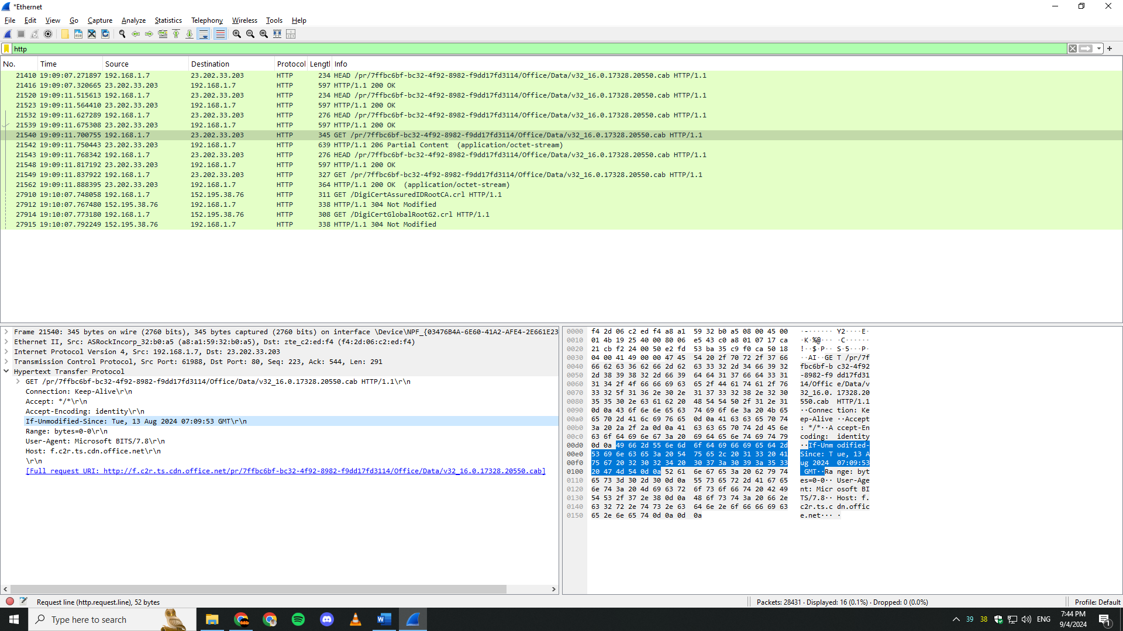

It only displayed the date which is Tue, 13 Aug, 2024 07:09:53 GMT

**11. What is the HTTP status code and phrase returned from the server in response to  
this second HTTP GET? Did the server explicitly return the contents of the file?  
Explain.**

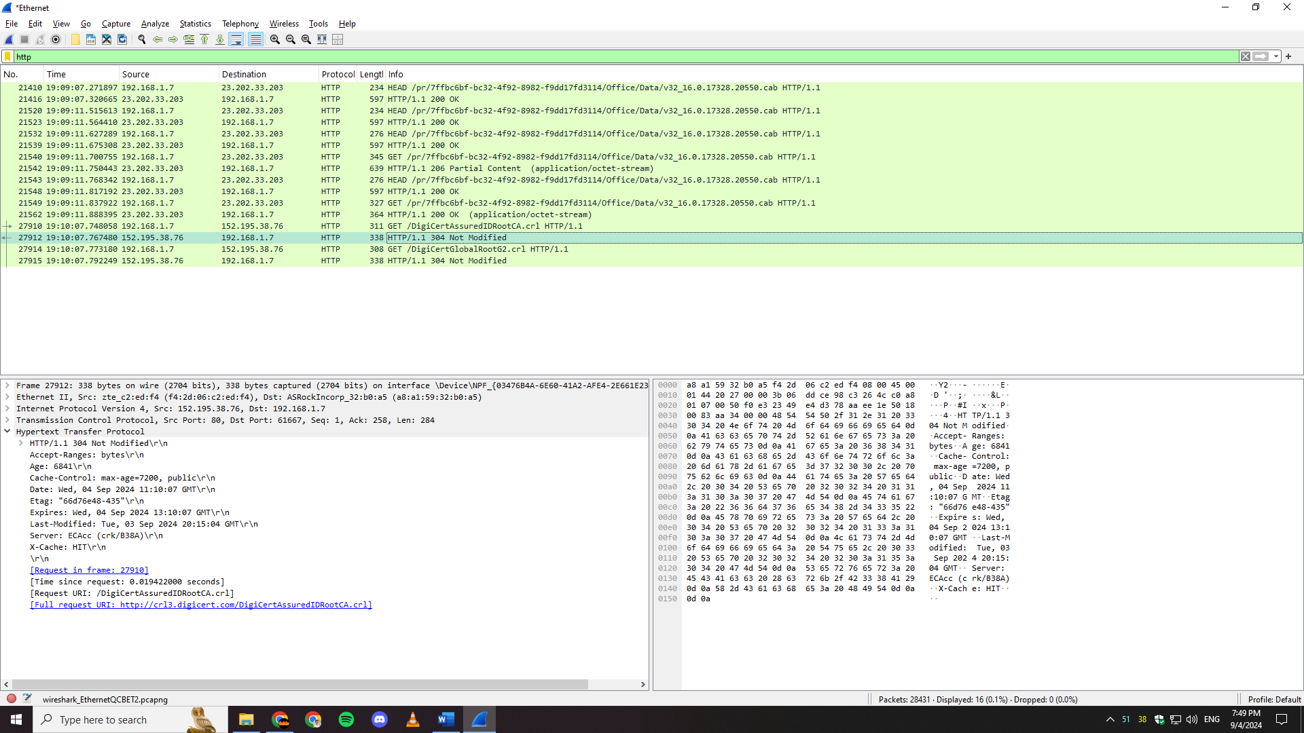

The status code is 304 Not Modified. It means that the server did not return the file content because it determined that the file had not changed since the last time it was retrieved by the browser. The browser can use the cached version of the file instead.